INTRODUCTION

Movement plays a crucial role in shaping the life histories of motile organisms (Dougherty et al., 2018; Nathan et al., 2008). An individual’s home range will dictate the amount and types of resources it has access to (Kelt & Van Vuren, 2001; Mueller & Fagan, 2008). Within their home range, individuals will encounter other organisms while searching for resources (Zuberogoitia et al., 2013). These encounters in turn will further shape their movement behavior (Bartumeus et al., 2005; Noonan et al., 2021). Inherently, movement patterns of organisms are tightly linked to ecological processes (Dougherty et al., 2018; Nathan et al., 2008; Smith et al., 2023). In that sense, understanding movement ecology is not relevant only from a natural history point of view, but also a key aspect of wildlife conservation (Allen & Singh, 2016; Block et al., 2011; Fraser et al., 2018)), especially for highly motile species.

Several factors drive animal’s movement including search for food (Zuberogoitia et al., 2013), nesting/den areas (Gregory et al., 2010), search for partners, avoid competitors (Hayward & Slotow, 2009), etc. However, in highly social species, social interactions are key in understanding how individuals distribute in the landscape. For instance, a study with capuchins showed that individuals modified their movement to reduce probability of encountering other individuals (Noonan et al., 2021). Another example where sociality determines movement behavior is in group-living species, where shared knowledge and decision-making can lead to collective motion (Strandburg-Peshkin et al., 2015) and/or more efficient movement ( Mueller et al., 2013; Harel et al., 2017; Jesmer et al., 2018). A species’ movement ecology is thus tightly intertwined with its social behaviour (Weber et al., 2021).

Although there have been recent significant advances in technology (Kays et al., 2015; Nathan et al., 2022) and methodologies (Calabrese et al., 2016; Fleming et al., 2016) to understand movement, several species remain understudied under this framework. This is of special concern for endangered and poorly studied species. As human encroachment expands into more pristine areas, decline of habitat quality and availability will continue to press already imperiled species. Understanding how this habitat reduction could affect group cohesion in social species still remains understudied.

Lowland tapirs are herbivores of the order Perissodactyla that can reach over 2.5 m in length and weigh up to 250 kg (Livet, 2012). Although lowland tapirs are widely distributed throughout South America (Cordeiro et al., 2016), their populations have experienced dramatic reductions and they are currently globally classified as Vulnerable to extinction (Varela et al. 2019), with some countries having higher endangered classifications (e.g. Endangered in Ecuador). Some recent studies have aimed at understanding movement ecology of lowland tapirs (Tobler, 2008: Ferreguetti et al., 2017; Fleming et al., 2019), which ultimately aids the species’ conservation. Despite this, knowledge gaps still remain, including their spatial distribution and sociality. Because of their large body size, large high-quality habitats are necessary to sustain their homeranges. However, understanding how sociality influences spatial distribution also impacts the amount of habitat needed to sustain a healthy population. Here, we use an extensive telemetry dataset collected over 22 years to describe the movement ecology and behavior of lowland tapirs (Tapirus terrestris) and how its social interactions vary within and between family units in the Pantanal, Cerrado, and Atlantic Forest biomes in southern Brazil.

METHODS
Movement data
The tracking data were collected in southern Brazil in the Pantanal biome as part of the Lowland Tapir Conservation Initiative. Tapirs were captured by darting from a distance, or by darting after using box or pitfall traps to restrain their movement. Animals were anesthetized following by Medici et al. (2014) and Fernandes-Santos et al. (2020). Reversal agents were administrated at the end of procedures. The procedures carried out during immobilization included the subcutaneous insertion of a microchip, morphometric measurements, sex and age class determination, physical examination, collection of biological samples for health and genetic studies, and placement of a telemetry collar on adults.
A total of 46 tapirs were tracked in the Pantanal biome between 2008 until 2019. Movement data was collected using VHF tracking (Telonics® MOD500) and GPS tracking (Telonics® TGW SOB and GPS IRIDIUM models). Tapirs equipped with VHF collars were monitored for 5 days per month with data collection concentrated during crepuscular times (at dawn, between 04:00–07:00 h, and at dusk between 17:00–20:00 h) as these periods are the two main peaks of tapir activity (Medici 2011). Each tapir was located every 30 min during the sampling periods. GPS collars were programmed to obtain a fix every hour and operated for a median of 15.4 months across all tagged tapirs. Complementary to the tapir location data, we collected 883 and 174 measurements from tags in fixed locations in the Pantanal and Cerrado, respectively in order to calibrate the measurement error of the GPS tracking collars.

Data calibration and cleaning
We used location data that was previously filtered and cleaned by Medici et al. (2022). To run a second verification on the data, we used the ctmm R package to plot the movement variogram for each tapir against the measurement error, identifying and removing potential outliers that remained present.

Home range estimation and sociality
To evaluate the degree of relatedness among family units and individuals, we first calculated individual home ranges for each tapir. We did this using the Continuous-Time Movement Model (CTMM) R package using the ctmm.select function. This function fits a series of CTMMs to location data using perturbative Hybrid Residual Maximum Likelihood pHREML (Fleming et al 2019) and chooses the best model using small-sample-sized corrected Akaike’s Information Criterion (AICc). The models used in this package are not sensitive to sampling frequency and they account for spatial and temporal autocorrelation (Blackwell et al. 2016, Fleming et al. 2014), which makes them robust regardless of the sample size of the data and frequency (Fleming et al. 2018). We calculated the 95% Home range area (km²) using Autocorrelated Kernel Density Estimation (hereon AKDE) [Fleming and Calabrese 2017, Noonan et al. 2019) and overlap values between individuals and family units using the overlap function in ctmm. We then tabulated overlap values in a matrix for all 46 individuals assessed. To further assess sociality, we calculated number of encounters and proximity between individuals, and compared values between and within family units. To calculate the number of encounters, we used distance values between the individuals. We determined encounters as distances less than 100 m between individuals. Finally, we calculated proximity values frequency as another indicator of sociality among tapirs. Proximity values were obtained using the proximity() function from the CTMM package. This function estimates the distance between individuals and compares these values against an average distance derived from several simulated paths that individuals could have taken, thus doing a pairwise comparison between simulated and actual data that is used to infer if individuals are staying closer to one another (<1), avoiding each other (>1), or their movement is independent (=1).

RESULTS
Home range estimation and sociality
We obtained location data from 46 individuals of lowland tapirs. GPS fix success rates were 75% in the Pantanal. The full dataset comprised 232,622 location estimates collected over a period of 22 years (Supplementary material).
Most tapirs showed some degree of overlap, within and between family units (Figure 1). However, the amount of overlap was considerably higher within family units (x̄ = 0.69) as compared to the overlap between different families (x̄ = 0.12, Figure 2). However, within family units the degree of overlap showed a wide variation (95% CI: 0.23-0.84), as opposed to between family units which remained more consistent (95% CI: 0-0.15).

Our results show that several individuals did not have encounters with other members at all, regardless of whether they belong or not to family units (261 Between, 14 Within, Figure 3) and of their degree of home range overlap. This may be explained by temporal partitioning between them. For the pairs of individuals that did show one encounter or more, our results suggest a slight positive pattern with home-range overlap within and between family units (Figure 3). However, we found no strong correlation between these variables based on our data (r= 0.43, p < 0.01 Within, r= 0.26, p < 0.01 Between). Albeit, our sample sizes were small and unevenly distributed (n_{within} = 18, n_{between} = 285), which may hinder our ability to interpret the outputs of our model.

Despite overall low encounter rates among conspecifics, most tapirs remained close to other individuals both within and between family units, regardless of home-range overlap (Figure 4), although the trend was stronger within family units. However, some individuals between family units also show avoidance patterns (proximity ratio (>1), thereby suggesting mixed results.

Figure 1. Degree of relatedness between individual tapirs
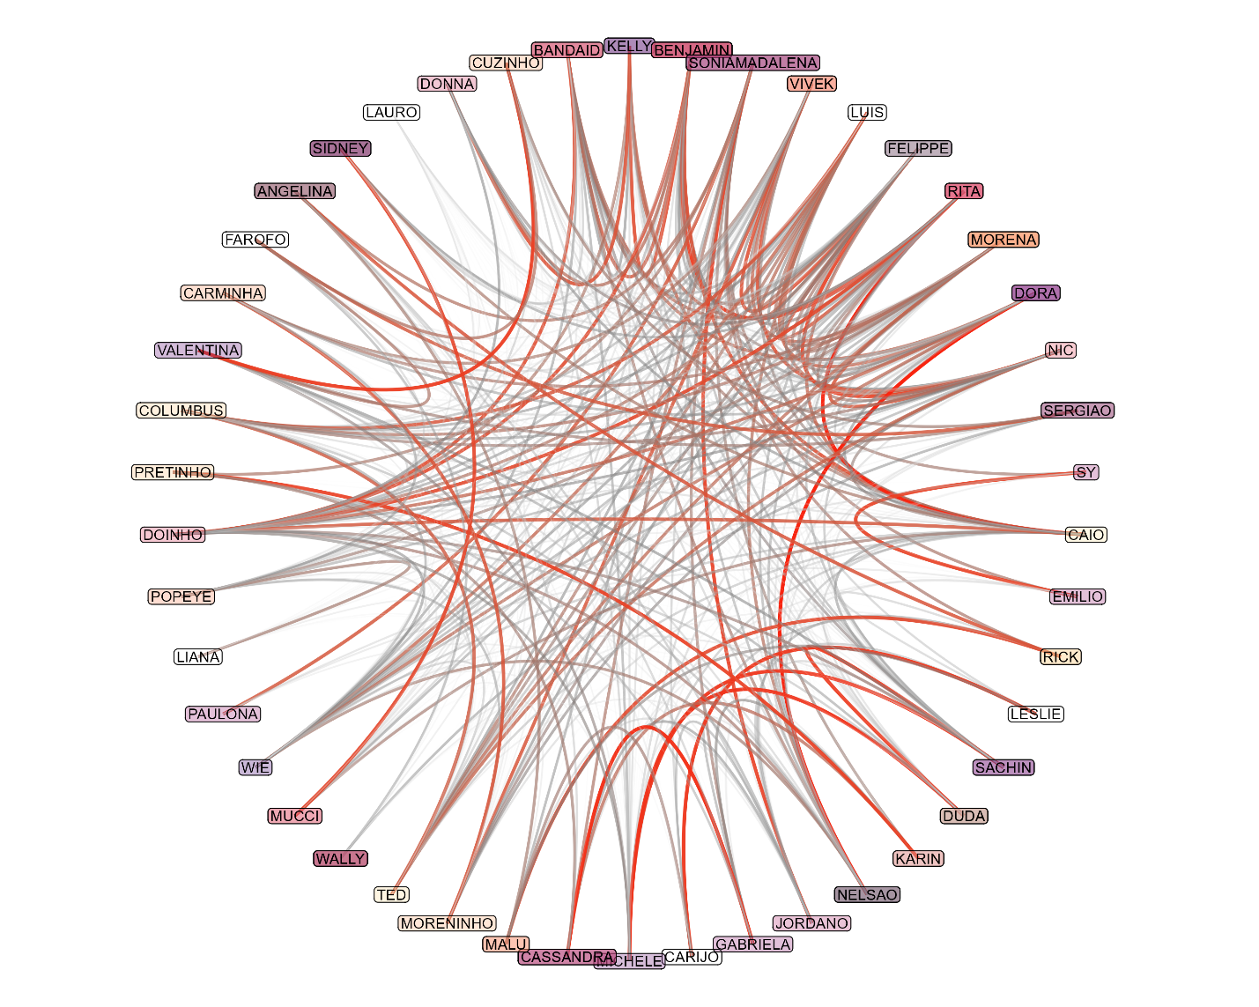

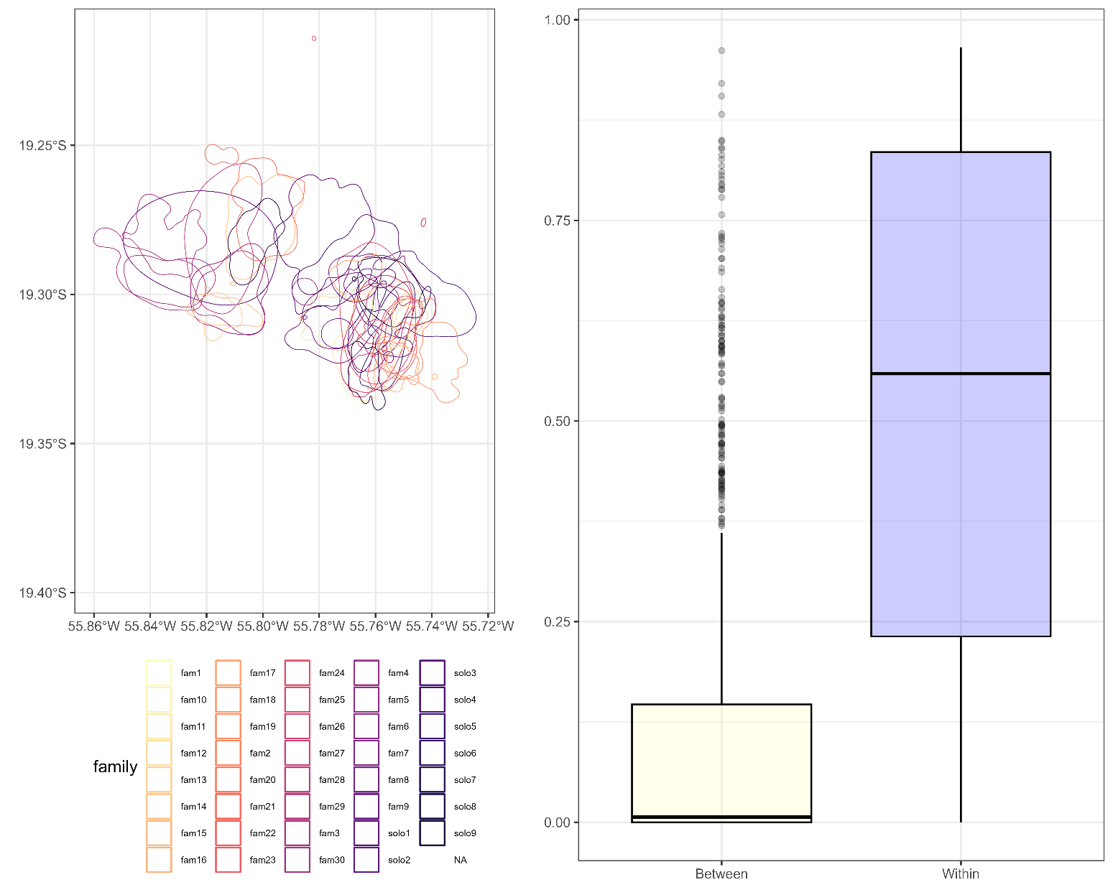
Figure 2. Family units and solo individuals distributed in the landscape (left panel) and degree of home-range overlap between and within families (right panel).

Figure 3. Number of encounters in relation to home-range overlap between and within families.
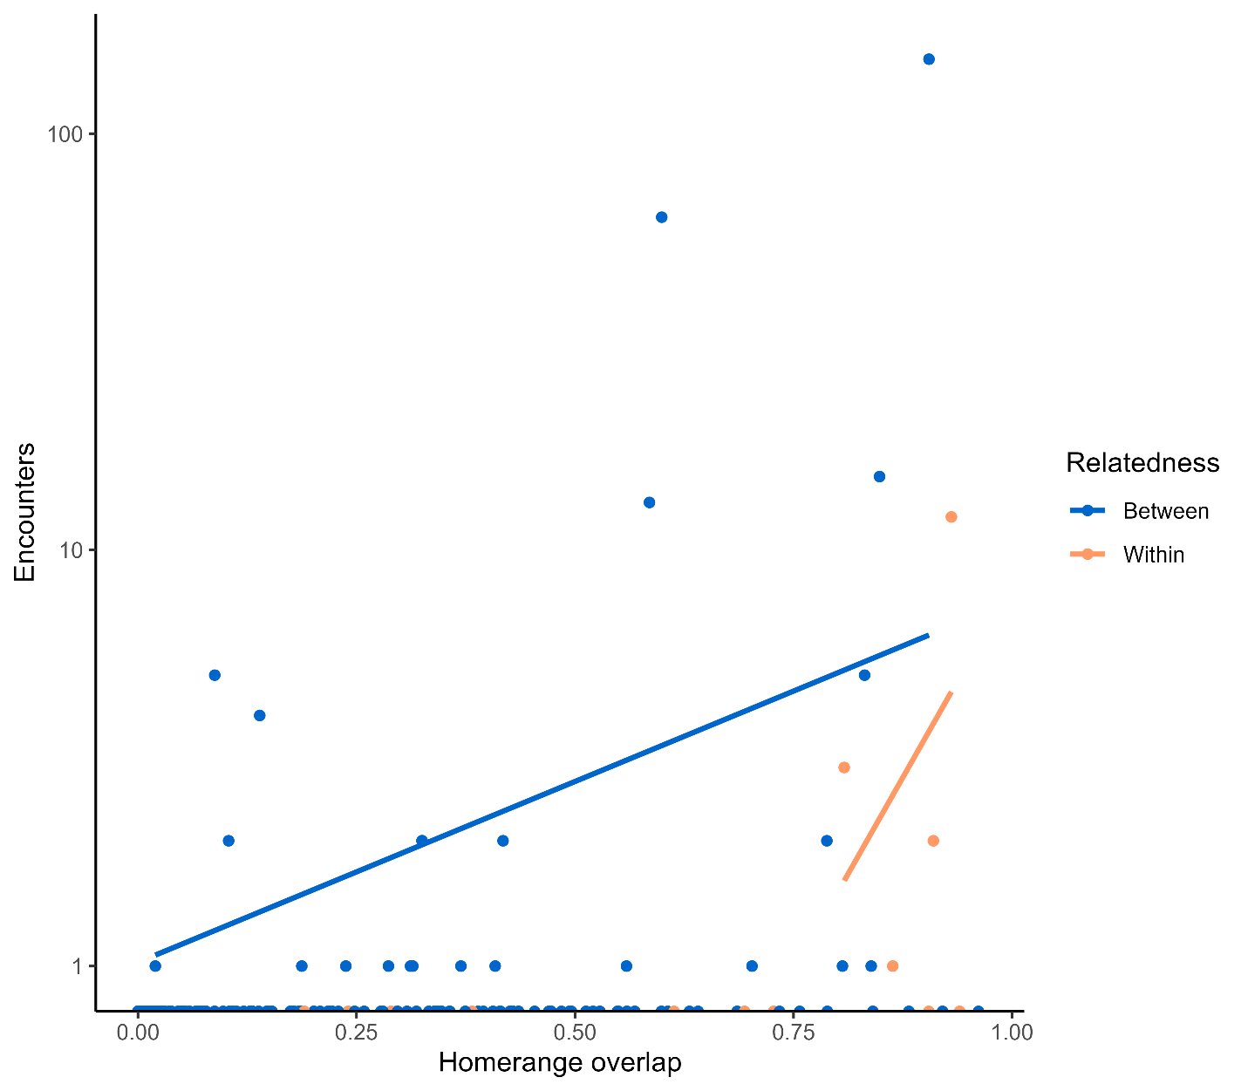

Figure 4. Proximity ratio in relation to home-range overlap between and within families.

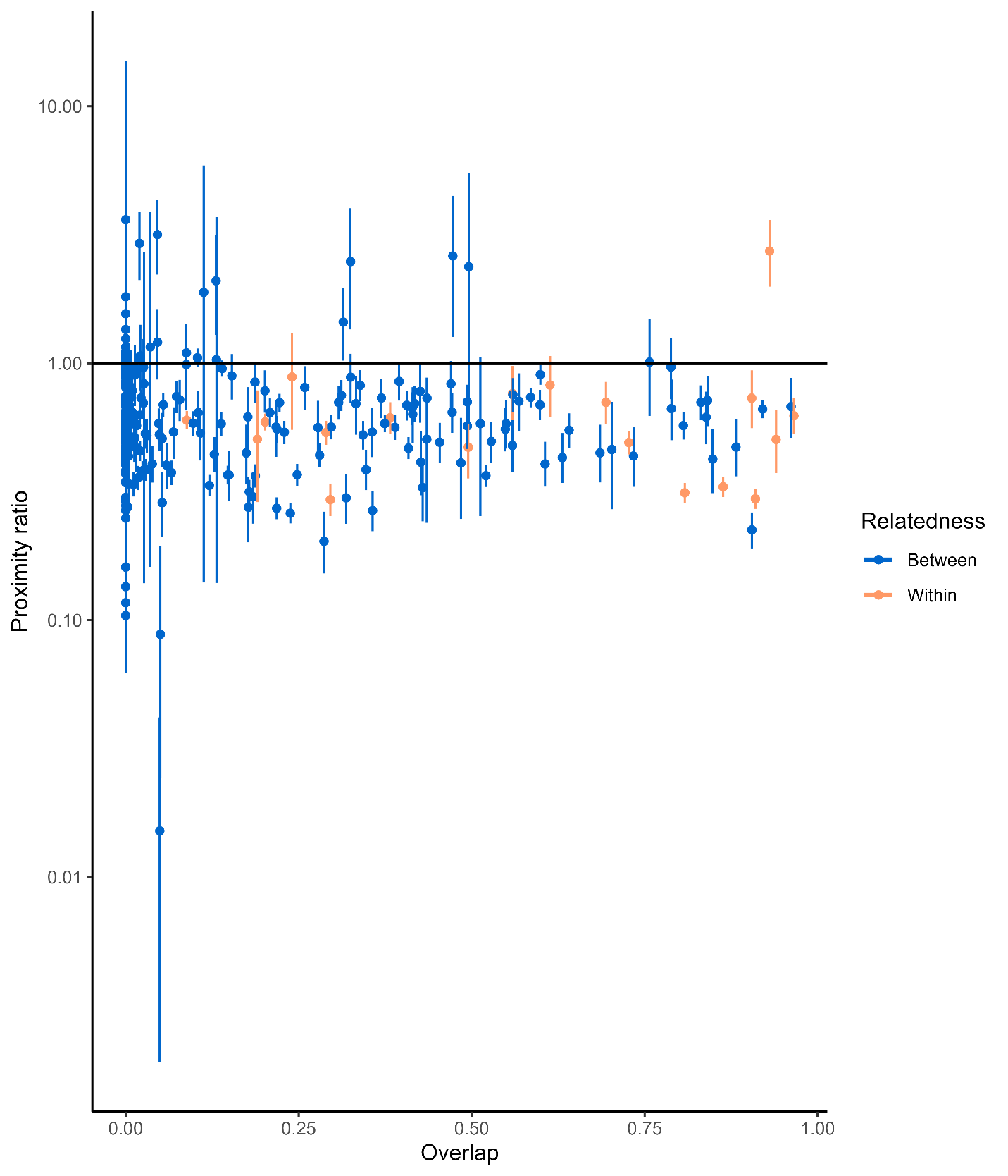

DISCUSSION

Broad-scale patterns in Tapirs social–spatial ecology

At a landscape level, we found considerable overlap between individual home ranges, with higher overlap within family units. These results suggest tapirs do not exhibit strong territoriality, but are likely more tolerant to individuals to which they are related. Our findings are similar to those of Pinho et al. (2014) with tapirs being tolerant to other individuals in their home range, however, unlike our study, they did not find an importance in relatedness when determining spatial distribution. This lack of territoriality can be due to unpredictable resources that are hard to defend (Isbell et al., 2021; Maher & Lott, 2000), or a high abundance of resources in the habitat, with no strong benefits of defending a territory (Grant, 1993). A high home range overlap due to high resource abundance in tapirs has been discussed by Foerster & Vaughan (2002), where apparently the fruiting season promotes group formation. These findings are consistent with the resource dispersion hypothesis (RDH), which predicts that if resources are not limited, multiple individuals can share the same space with conspecifics (Macdonald, 1983; Macdonald & Johnson, 2015; Newsome et al., 2013). This pattern of lack of territoriality is supported by findings by Medici et al., (2022) where lowland tapirs – particularly in the Pantanal region- had small home-range sizes (<10 km²), which suggests they are not defending large areas. These results are also similar to those observed in other mammal species like Giant anteaters (Chhen et al., 2024).

Fine-scale interactions between Tapirs

Our findings on the fine-scale interactions between individuals support these earlier works. On average, the proximity ratios and encounter rates suggest that individuals do not seem to avoid nor followed each other. The findings were similar regardless of relatedness, indicating that kinship may not play an important role in this species. Instead, both encounter rates and proximity seem to be more likely governed by home range overlap, rather than relatedness. Collectively, these findings suggest that lowland tapirs are a solitary species, which is supported by other studies (Oliveira-Santos et al., 2010; Pinho et al., 2014).
Despite our findings, daily temporal partitioning may be also acting to reduce overlap between individuals. Unfortunately, the resolution of our temporal data does not allow to tease apart this hypothesis. In addition, seasonality may also affect the behavior of tapirs. For instance, tapirs living in the Pantanal occupy a near pristine ecosystem but must cope with significant seasonal flooding (Medici et al., 2022). This condition results in higher concentration of individuals in limited areas by clumping food resources and decreasing local diversity (Cjr. Alho, 2008), ultimately increasing their spatial overlap and possibly their encounter rates.

While our findings support tapirs as mostly solitary species, the phase of the life cycle may also play an important role in determining sociality. For instance, capybaras tend to display higher sociality when individuals are under their mature stage. As soon as sub-adults- especially males- reach sexual maturity, the dominant male in the group excludes the sub-adult individuals as they become competition for mating (C. J. R. Alho & Silva, 2012). Evaluating differences between sexes and age-classes may provide more insight into social structure and hierarchy of this understudied species. Finally, our results are limited to the Pantanal region. For example, Medici et al., (2022) showed that male and young individuals in the Cerrado and Atlantic Forest regions have larger homeranges than those individuals of Pantanal. Comparing home-range overlap and encounter rates between these individuals would therefore be crucial to expand our results and get a more comprehensive understanding of the general sociality of tapirs. The current research sheds light into the social behavior of this species, however more work needs to be done to extrapolate these results to a species level.

Conservation implications

Lowland tapirs are a poorly understood species despite their Vulnerable status and population reduction. The Pantanal region harbors several ranching areas for cattle farming. Due to poor ranching practices, this region is very prone to human-induced wildfires which destroys habitat for a wide array of species including lowland tapirs. Deforestation is also encroaching to convert natural habitats to pastures for cattle grazing (C. J. R. Alho & Silva, 2012), further exacerbating the problem. With already small home-ranges, and naturally shrinking habitat during the flooding season, human disturbance may pose a major challenge for lowland tapirs. If their food and space availability decreases, individuals may need to increase overlap and encounter rates, thereby increasing competition. This could lead to skewing populations favoring only adult and dominant males. Although this increases current mating opportunities, a possible lack of sub-adult recruitment can have an effect in the long-term population.

REFERENCES

Alho, C. J. R., & Silva, J. S. V. (2012). Effects of Severe Floods and Droughts on Wildlife of the Pantanal Wetland (Brazil)—A Review. Animals, 2(4), 591–610. https://doi.org/10.3390/ani2040591
Alho, Cjr. (2008). Biodiversity of the Pantanal: Response to seasonal flooding regime and to environmental degradation. Brazilian Journal of Biology, 68(4 suppl), 957–966. https://doi.org/10.1590/S1519-69842008000500005
Allen, A. M., & Singh, N. J. (2016). Linking Movement Ecology with Wildlife Management and Conservation. Frontiers in Ecology and Evolution, 3. https://doi.org/10.3389/fevo.2015.00155
Bartumeus, F., Da Luz, M. G. E., Viswanathan, G. M., & Catalan, J. (2005). ANIMAL SEARCH STRATEGIES: A QUANTITATIVE RANDOM-WALK ANALYSIS. Ecology, 86(11), 3078–3087. https://doi.org/10.1890/04-1806
Block, B. A., Jonsen, I. D., Jorgensen, S. J., Winship, A. J., Shaffer, S. A., Bograd, S. J., Hazen, E. L., Foley, D. G., Breed, G. A., Harrison, A.-L., Ganong, J. E., Swithenbank, A., Castleton, M., Dewar, H., Mate, B. R., Shillinger, G. L., Schaefer, K. M., Benson, S. R., Weise, M. J., … Costa, D. P. (2011). Tracking apex marine predator movements in a dynamic ocean. Nature, 475(7354), 86–90. https://doi.org/10.1038/nature10082
Calabrese, J. M., Fleming, C. H., & Gurarie, E. (2016). ctmm: An r package for analyzing animal relocation data as a continuous‐time stochastic process. Methods in Ecology and Evolution, 7(9), 1124–1132. https://doi.org/10.1111/2041-210X.12559
Chhen, A., Bertassoni, A., Desbiez, A. L. J., & Noonan, M. J. (2024). The socio‐spatial ecology of giant anteaters in the Brazilian Cerrado. Journal of Zoology, 324(1), 50–62. https://doi.org/10.1111/jzo.13195
Cordeiro, J. L. P., Fragoso, J. M. V., Crawshaw, D., & Oliveira, L. F. B. (2016). Lowland tapir distribution and habitat loss in South America. PeerJ, 4, e2456. https://doi.org/10.7717/peerj.2456
Dougherty, E. R., Seidel, D. P., Carlson, C. J., Spiegel, O., & Getz, W. M. (2018). Going through the motions: Incorporating movement analyses into disease research. Ecology Letters, 21(4), 588–604. https://doi.org/10.1111/ele.12917
Ferreguetti, Á. C., Tomás, W. M., & Bergallo, H. G. (2017). Density, occupancy, and detectability of lowland tapirs, Tapirus terrestris, in Vale Natural Reserve, southeastern Brazil. Journal of Mammalogy, 98(1), 114–123. https://doi.org/10.1093/jmammal/gyw118
Fleming, C. H., Fagan, W. F., Mueller, T., Olson, K. A., Leimgruber, P., & Calabrese, J. M. (2016). Estimating where and how animals travel: An optimal framework for path reconstruction from autocorrelated tracking data. Ecology, 97(3), 576–582. https://doi.org/10.1890/15-1607.1
Fleming, C. H., Noonan, M. J., Medici, E. P., & Calabrese, J. M. (2019). Overcoming the challenge of small effective sample sizes in home‐range estimation. Methods in Ecology and Evolution, 10(10), 1679–1689. https://doi.org/10.1111/2041-210X.13270
Foerster, C. R., & Vaughan, C. (2002). Home Range, Habitat Use, and Activity of Baird’s Tapir in Costa Rica¹. Biotropica, 34(3), 423–437. https://doi.org/10.1111/j.1744-7429.2002.tb00556.x
Fraser, K. C., Davies, K. T. A., Davy, C. M., Ford, A. T., Flockhart, D. T. T., & Martins, E. G. (2018). Tracking the Conservation Promise of Movement Ecology. Frontiers in Ecology and Evolution, 6, 150. https://doi.org/10.3389/fevo.2018.00150
Grant, J. W. A. (1993). Whether or not to defend? The influence of resource distribution. Marine Behaviour and Physiology, 23(1–4), 137–153. https://doi.org/10.1080/10236249309378862
Gregory, S. C., Haegen, W. M. V., Chang, W. Y., & West, S. D. (2010). Nest Site Selection by Western Gray Squirrels at Their Northern Range Terminus. The Journal of Wildlife Management, 74(1), 18–25. https://doi.org/10.2193/2009-021
Harel, R., Spiegel, O., Getz, W. M., & Nathan, R. (2017). Social foraging and individual consistency in following behaviour: Testing the information centre hypothesis in free-ranging vultures. Proceedings of the Royal Society B: Biological Sciences, 284(1852), 20162654. https://doi.org/10.1098/rspb.2016.2654
Hayward, M. W., & Slotow, R. (2009). Temporal Partitioning of Activity in Large African Carnivores: Tests of Multiple Hypotheses. South African Journal of Wildlife Research, 39(2), 109–125. https://doi.org/10.3957/056.039.0207
Isbell, L. A., Bidner, L. R., Loftus, J. C., Kimuyu, D. M., & Young, T. P. (2021). Absentee owners and overlapping home ranges in a territorial species. Behavioral Ecology and Sociobiology, 75(1), 21. https://doi.org/10.1007/s00265-020-02945-7
Jesmer, B. R., Merkle, J. A., Goheen, J. R., Aikens, E. O., Beck, J. L., Courtemanch, A. B., Hurley, M. A., McWhirter, D. E., Miyasaki, H. M., Monteith, K. L., & Kauffman, Matthew. J. (2018). Is ungulate migration culturally transmitted? Evidence of social learning from translocated animals. Science, 361(6406), 1023–1025. https://doi.org/10.1126/science.aat0985
Kays, R., Crofoot, M. C., Jetz, W., & Wikelski, M. (2015). Terrestrial animal tracking as an eye on life and planet. Science, 348(6240), aaa2478. https://doi.org/10.1126/science.aaa2478
Kelt, D. A., & Van Vuren, D. H. (2001). The Ecology and Macroecology of Mammalian Home Range Area. The American Naturalist, 157(6), 637–645. https://doi.org/10.1086/320621
Livet, J. (2012). WilsonDE, MittermeierRA, editors. 2011. Handbook of the Mammals of the World. Vol. 2. Hoofed Mammals. Barcelona: Lynx Edicions. Zoo Biology, 31(5), 621–623. https://doi.org/10.1002/zoo.21021
Macdonald, D. W. (1983). The ecology of carnivore social behaviour. Nature, 301(5899), 379–384. https://doi.org/10.1038/301379a0
Macdonald, D. W., & Johnson, D. D. P. (2015). Patchwork planet: The resource dispersion hypothesis, society, and the ecology of life. Journal of Zoology, 295(2), 75–107. https://doi.org/10.1111/jzo.12202
Maher, C. R., & Lott, D. F. (2000). A Review of Ecological Determinants of Territoriality within Vertebrate Species. The American Midland Naturalist, 143(1), 1–29. https://doi.org/10.1674/0003-0031(2000)143[0001:AROEDO]2.0.CO;2
Medici, E. P., Mezzini, S., Fleming, C. H., Calabrese, J. M., & Noonan, M. J. (2022). Movement ecology of vulnerable lowland tapirs between areas of varying human disturbance. Movement Ecology, 10(1), 14. https://doi.org/10.1186/s40462-022-00313-w
Mueller, T., & Fagan, W. F. (2008). Search and navigation in dynamic environments – from individual behaviors to population distributions. Oikos, 117(5), 654–664. https://doi.org/10.1111/j.0030-1299.2008.16291.x
Mueller, T., O’Hara, R. B., Converse, S. J., Urbanek, R. P., & Fagan, W. F. (2013). Social Learning of Migratory Performance. Science, 341(6149), 999–1002. https://doi.org/10.1126/science.1237139
Nathan, R., Getz, W. M., Revilla, E., Holyoak, M., Kadmon, R., Saltz, D., & Smouse, P. E. (2008). A movement ecology paradigm for unifying organismal movement research. Proceedings of the National Academy of Sciences, 105(49), 19052–19059. https://doi.org/10.1073/pnas.0800375105
Nathan, R., Monk, C. T., Arlinghaus, R., Adam, T., Alós, J., Assaf, M., Baktoft, H., Beardsworth, C. E., Bertram, M. G., Bijleveld, A. I., Brodin, T., Brooks, J. L., Campos-Candela, A., Cooke, S. J., Gjelland, K. Ø., Gupte, P. R., Harel, R., Hellström, G., Jeltsch, F., … Jarić, I. (2022). Big-data approaches lead to an increased understanding of the ecology of animal movement. Science, 375(6582), eabg1780. https://doi.org/10.1126/science.abg1780
Newsome, T. M., Ballard, G., Dickman, C. R., Fleming, P. J. S., & Van De Ven, R. (2013). Home range, activity and sociality of a top predator, the dingo: A test of the Resource Dispersion Hypothesis. Ecography, 36(8), 914–925. https://doi.org/10.1111/j.1600-0587.2013.00056.x
Noonan, M. J., Martinez‐Garcia, R., Davis, G. H., Crofoot, M. C., Kays, R., Hirsch, B. T., Caillaud, D., Payne, E., Sih, A., Sinn, D. L., Spiegel, O., Fagan, W. F., Fleming, C. H., & Calabrese, J. M. (2021). Estimating encounter location distributions from animal tracking data. Methods in Ecology and Evolution, 12(7), 1158–1173. https://doi.org/10.1111/2041-210X.13597
Oliveira-Santos, L. G. R., Machado-Filho, L. C. P., Tortato, M. A., & Brusius, L. (2010). Influence of extrinsic variables on activity and habitat selection of lowland tapirs (Tapirus terrestris) in the coastal sand plain shrub, southern Brazil. Mammalian Biology, 75(3), 219–226. https://doi.org/10.1016/j.mambio.2009.05.006
Pinho, G. M., Gonçalves Da Silva, A., Hrbek, T., Venticinque, E. M., & Farias, I. P. (2014). Kinship and Social Behavior of Lowland Tapirs (Tapirus terrestris) in a Central Amazon Landscape. PLoS ONE, 9(3), e92507. https://doi.org/10.1371/journal.pone.0092507
Smith, B. J., MacNulty, D. R., Stahler, D. R., Smith, D. W., & Avgar, T. (2023). Density‐dependent habitat selection alters drivers of population distribution in northern Yellowstone elk. Ecology Letters, 26(2), 245–256. https://doi.org/10.1111/ele.14155
Strandburg-Peshkin, A., Farine, D. R., Couzin, I. D., & Crofoot, M. C. (2015). Shared decision-making drives collective movement in wild baboons. Science, 348(6241), 1358–1361. https://doi.org/10.1126/science.aaa5099
Weber, S. B., Richardson, A. J., Brown, J., Bolton, M., Clark, B. L., Godley, B. J., Leat, E., Oppel, S., Shearer, L., Soetaert, K. E. R., Weber, N., & Broderick, A. C. (2021). Direct evidence of a prey depletion “halo” surrounding a pelagic predator colony. Proceedings of the National Academy of Sciences, 118(28), e2101325118. https://doi.org/10.1073/pnas.2101325118
Zuberogoitia, I., González-Oreja, J. A., Martínez, J. E., Zabala, J., Gómez, I., & López-López, P. (2013). Foraging movements of Eurasian griffon vultures (Gyps fulvus): Implications for supplementary feeding management. European Journal of Wildlife Research, 59(3), 421–429. https://doi.org/10.1007/s10344-012-0687-2

APPENDIX

